**Design Document: Web Based Car Rental App Eindhoven Rent**

**Felix Morenc**

**Choice of Language**

For this project, I’ve chosen to use a combination of frameworks that utilise Java, Javascript and HTML, with a database choice of MySQL. From the front-end perspective of Javascript and HTML, I chose to use these as they’re the most widely utilised languages when it comes to web design and applications, thus I can ensure the highest amount of compatibility and have a foundation of familiarity from my first two semesters which means I have a basis to start off when designing and producing the web app for the client. In terms of the choice to implement Java for the back end logic of the application, I did this as it was the language I was recommended to use and have been receiving the most training in. The decision to chose MySQL as the DB format was similarly motivated, as it’s a language that I have a lot of experience with and can do all the functionality that I require out of a web app such as the one that I will be producing for my client EIndhoven Rent.

**Frameworks Utilised**

Now after choosing the languages I will be coding in I had to make decisions on the frameworks I was going to use to produce the application. In the Java back-end, I decided to use Spring Boot. This was a decision I made after doing further research into the subject, and discovered that Spring Boot could handle all the functionality I required out of my application, and had a vast online presence in regards to tutorials and other assistance should I need to make use of that. Regarding the front-end choice, I decided to go with React. This was a bit of a shot in the dark for me, as I had no experience with Javascript frameworks, but after doing research and personally trying out a number of alternatives such as Angular or Vue, I found that for me React was the most logical choice and I found had a good selection of online resources that I could make use of throughout the development of my application

**Testing Plan**

In this project I plan to make use of various strategies to test, such as unit, integration and acceptance testing. I’ll be doing this to ensure that as development goes on the project is fully functional. I’ll ensure this is accomplished as well by implementing CI on my gitlab repo which will ensure that I don’t wind up pushing non-functional code to the repository

**C4 Diagram**

Tier 1:

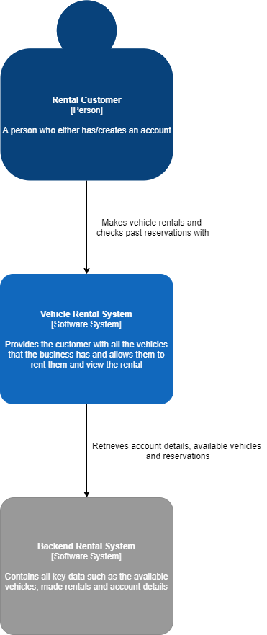

Tier 2:

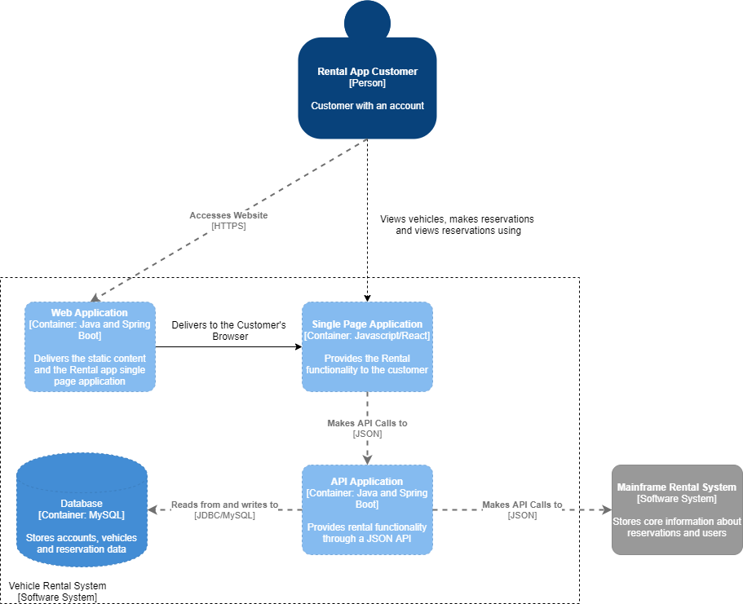

Tier 3:

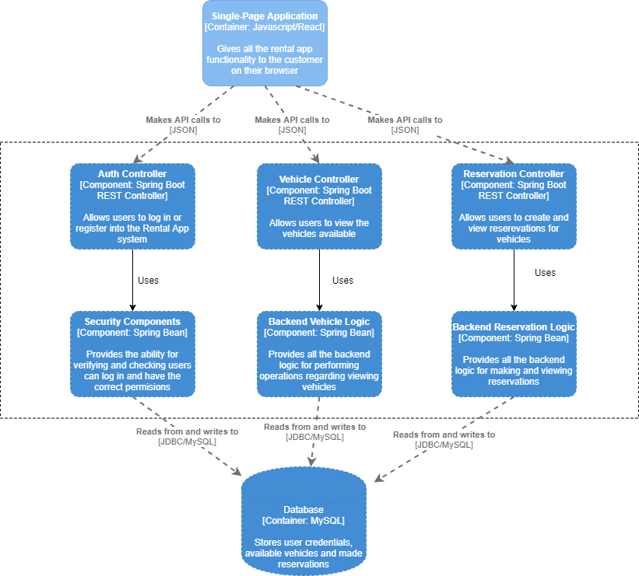

Tier 4:

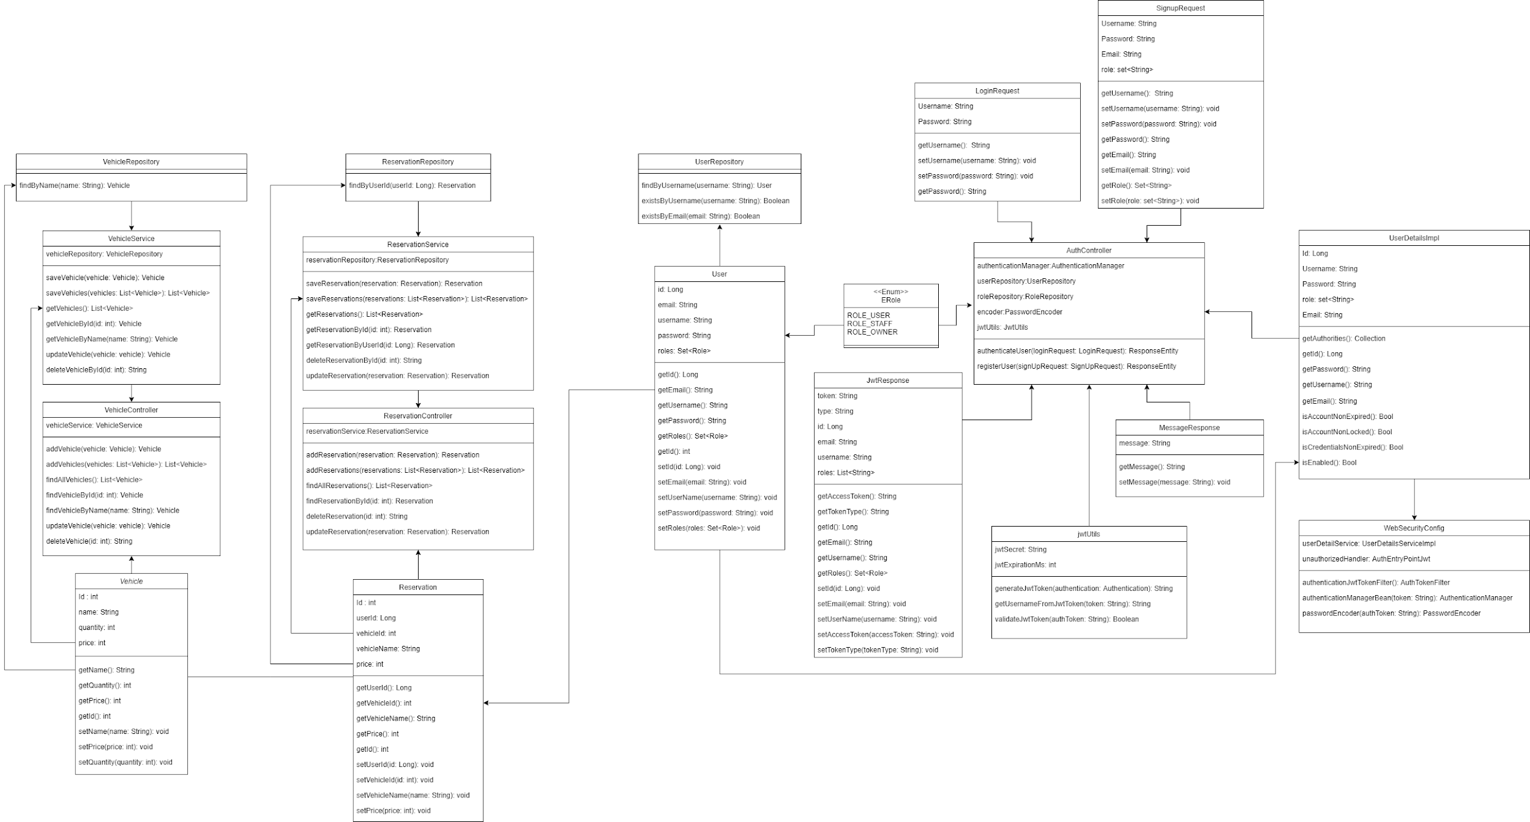

**UML Diagram**



**Wireframes**

Home Page:

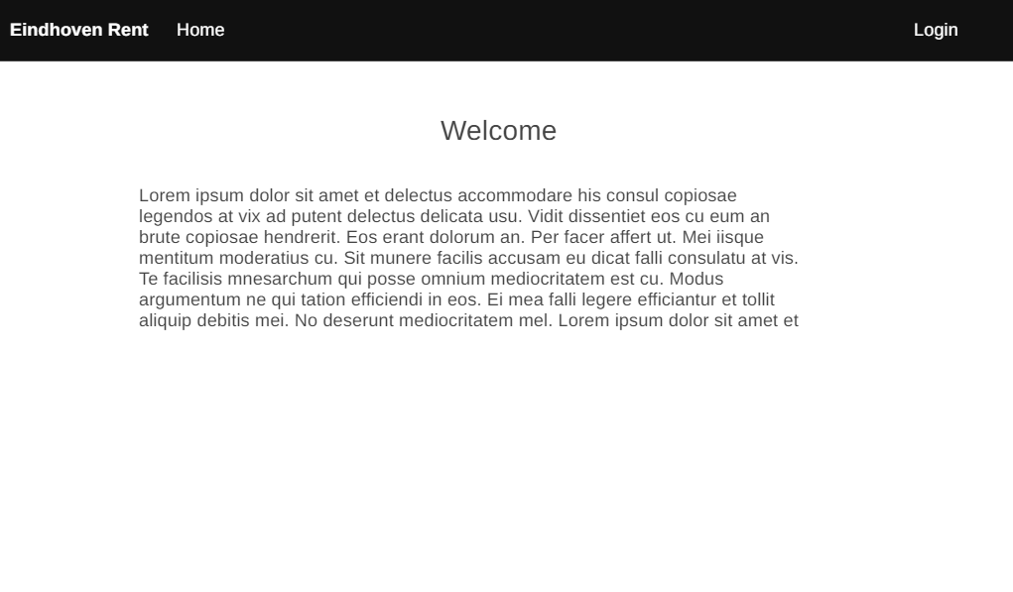

Login Page:

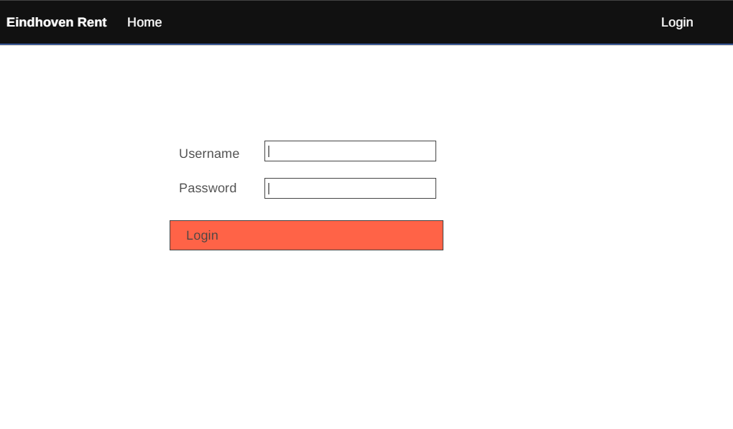

Register Page:

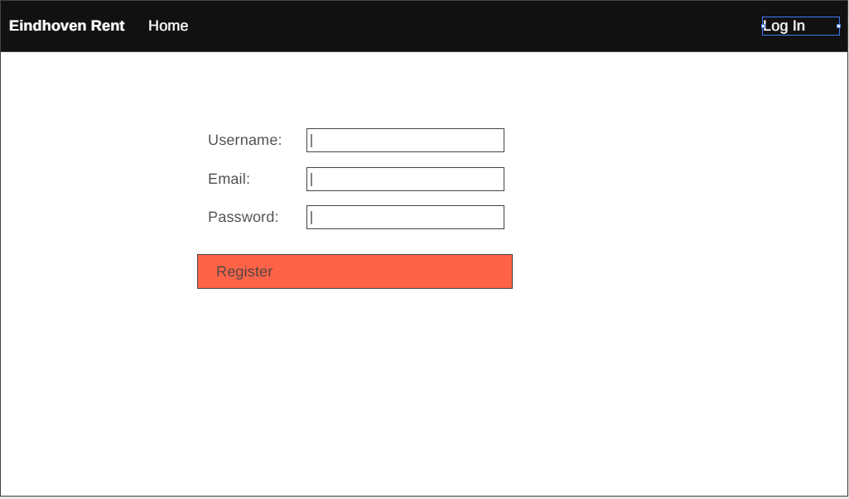

View Vehicles (User):

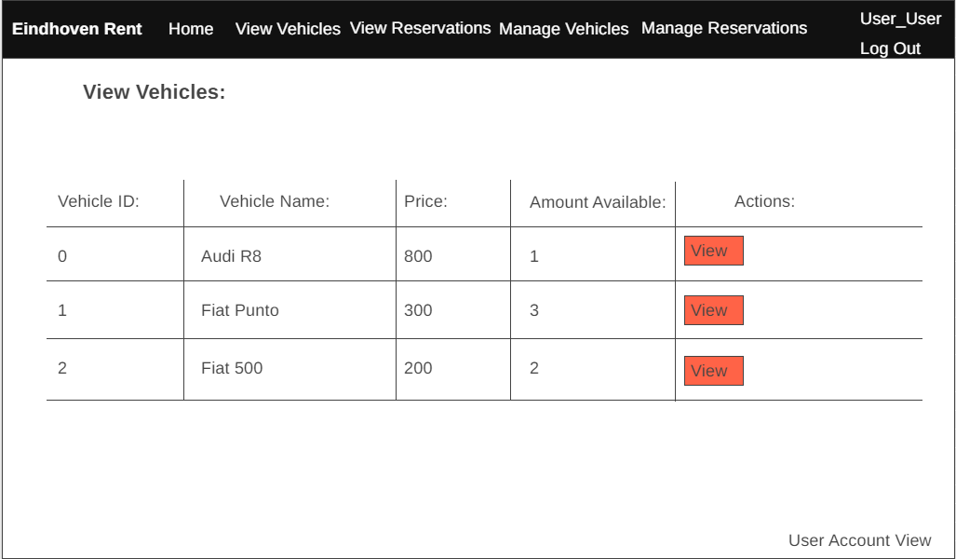

Make Reservation(User):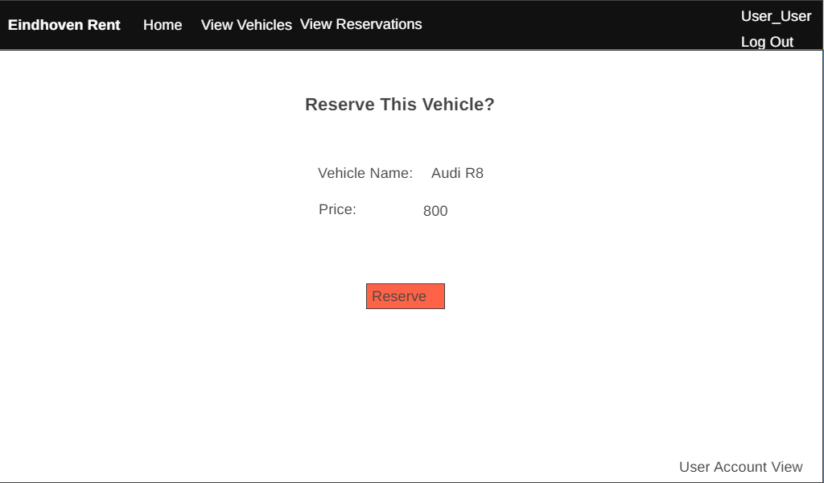

View Reservations(User):

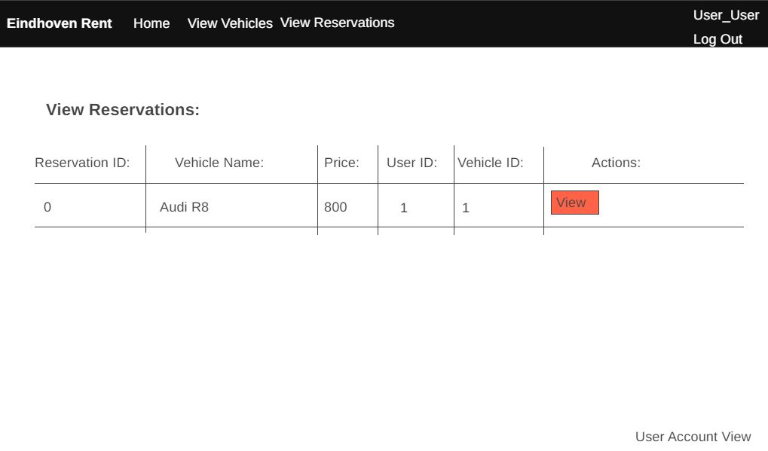

Manage Vehicles(Staff):

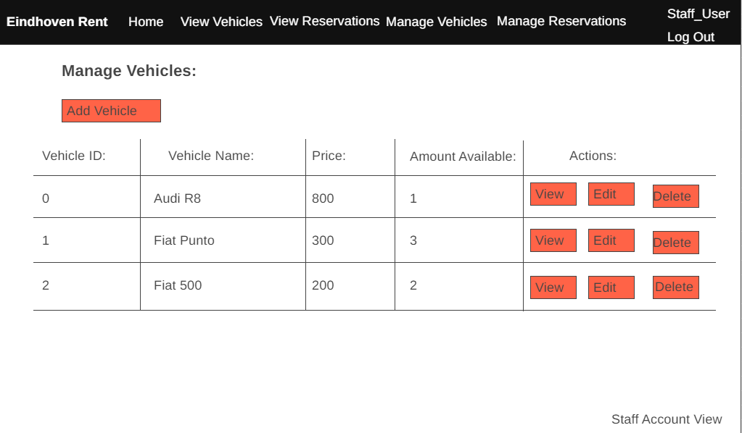

Create/Edit Vehicle(Staff):

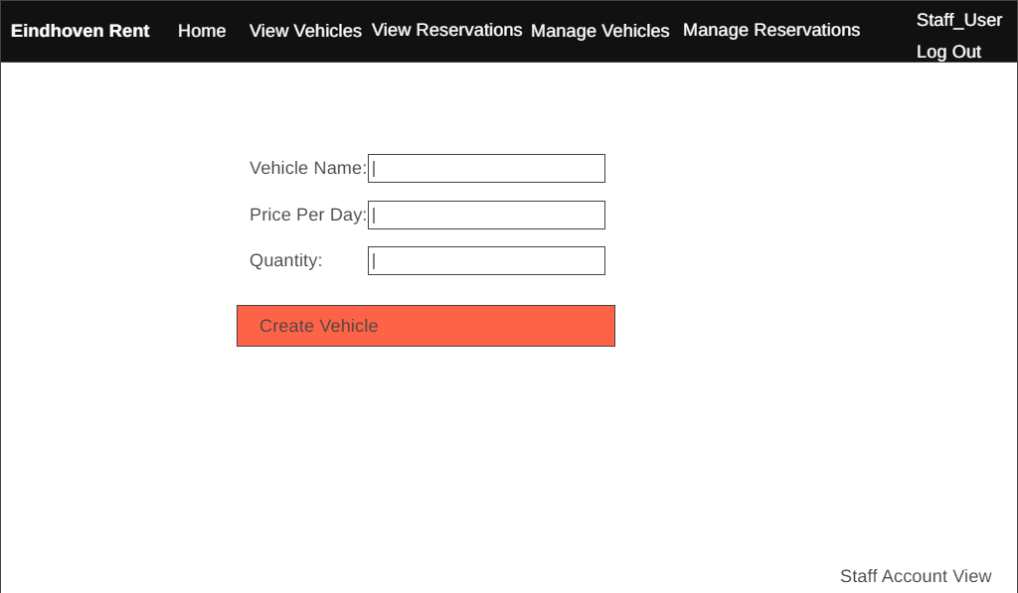

Manage Reservations (Staff):

